______________________________________________________________________________________
As the Fire Department prepares to further enhance safety through the implementation of the Motorola® Personnel Accountability System, it has become necessary to track changes to crew assignments in real-time.
Presently the Fire Department has exhausted efforts through our vendors and resources to automate a crew rostering process and have not yet been able to accomplish the necessary accuracy in position assignments. For this reason, it has now become necessary for each Officer to list their crew member’s duty assignment at their Mobile Data Computer (MDC) login screen before 0830 hrs. each day (start of duty tour) AND adjust crew assignments as any staffing changes occur throughout the tour of duty. This must be accomplished for each fire-apparatus assigned to a fire station that has an MDC. Crew lists will show on the MDC login screen on February 1st, 2023. A report will be automated to run at 0830 hrs. to assist with correcting discrepancies and ensure compliance.
Our partner Cities have been rostering their personnel through their MDC since we implemented the new CAD/Mobile software with no problems or system anomalies.
To limit change, this task will be performed during the daily truck check, immediately after rebooting the MDC, at the software login screen. The daily reboot will ensure each MDC has the most recent maps, unit list and crew list.
The exceptions to the revision of the crew assignments are when a member or members are directed to:
- “Ride in” on a Rescue to assist with patient care
- Directed to operate ancillary, not normally staffed, none MDC’d, support units (Boats, ATV’s/UTV’s, Woods Trucks, Rehab, etc.)
These required rostering tasks will ensure that the CAD/Mobile has a complete roster in fairly “real time” with information as to who is on what pieces of apparatus for a tour of duty. Resultant from this change, should an adverse incident and/or a “Mayday” be transmitted, the Incident Commander (IC) can identify how many members may be at risk, what unit(s) these individuals are assigned to, and how many members may need assistance and/or rescue. Once implemented, the Motorola® Personnel Accountability System will additionally use this rostering to significantly aid in the conduction of Personnel Accountability Reports (PAR’s) by reducing the time to complete a PAR to just seconds as compared to minutes they can now take.

Instructions:

Users will follow their normal activity of rebooting their MDC during their daily truck check. They will select their “Radio Call Sign” and “Vehicle ID” but with the additional step of selecting their crew members. Below the “Vehicle ID”, users will have a list on the left of SCFD crew members.

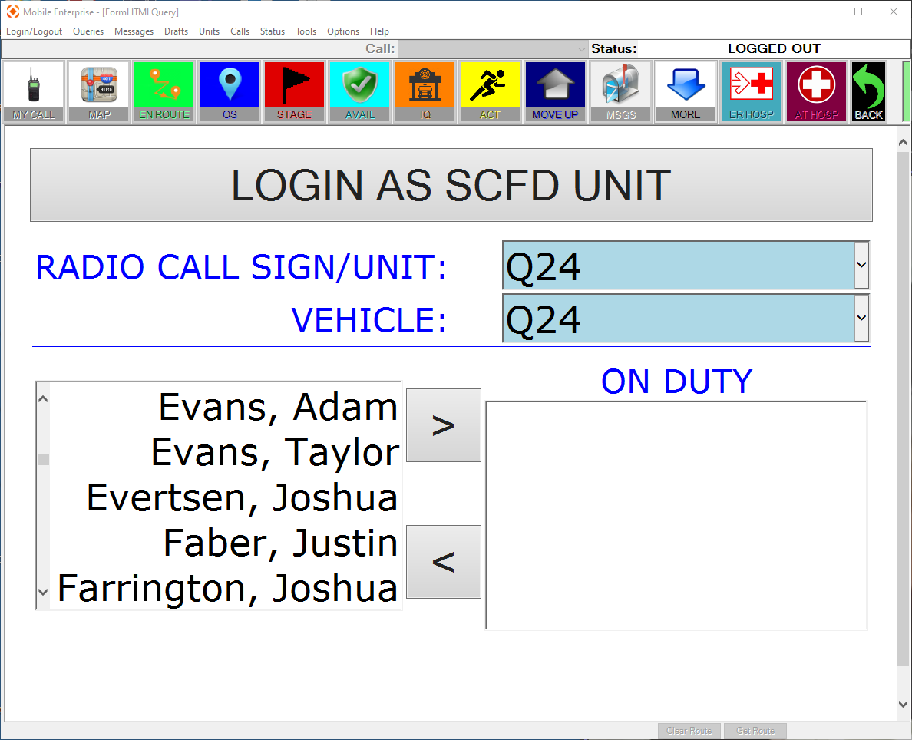

From the list on the left:

- Scroll down, or type the first letter of the last name, to locate the first person
- Select the user. The selected name will be highlighted
- Click the top > arrow to move the user to the right “ON DUTY” list
- Repeat steps 1-3 for each crew member
- A member in the right “ON DUTY” list can be removed by selecting the member, then clicking the bottom < arrow button
- Once all crew members are added, select “LOGIN AS SCFD UNIT”

If a crew member is missing, check for software updates and ensure a reboot has been performed. If a crew member is still missing, login with the crew members that can be selected, then send an email with the missing crew members full name AND employee ID to CADsupport@seminolecountyfl.gov

A completed entry would look like the below screenshot.
